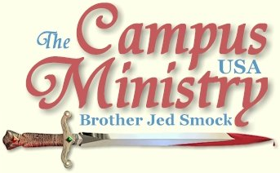
brojed.org
brojed@aol.com
573-999-0347
The Year of Ministry in Pictures
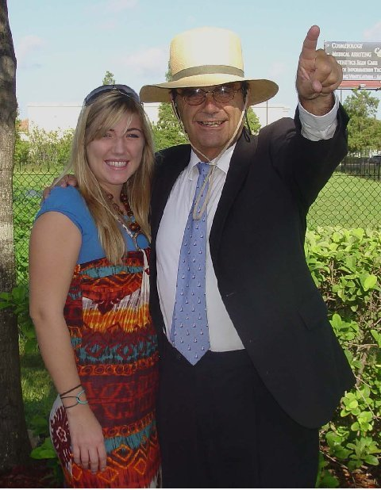
Charlotte and Dad Leaving for Ghana West Africa, August 2009

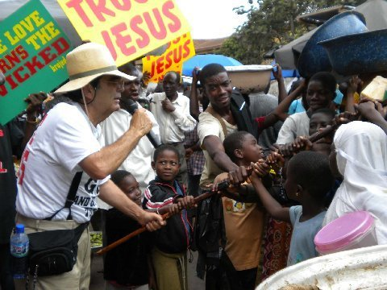
...Prayers for Salvation

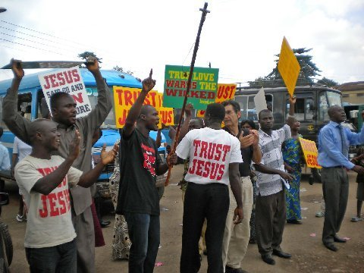

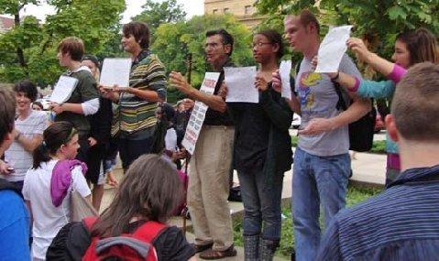
Kansas State University, August 27, 2009

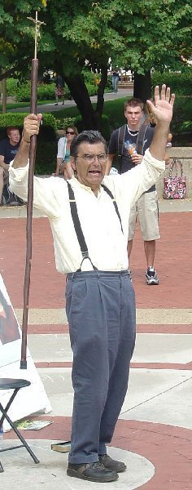
Mizzou August 2009

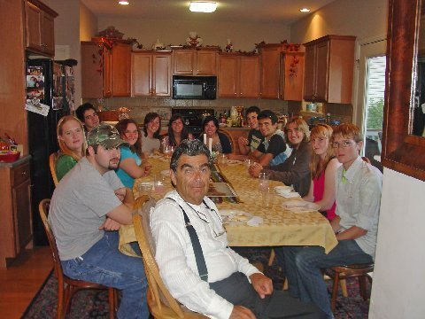
Open House August 2009

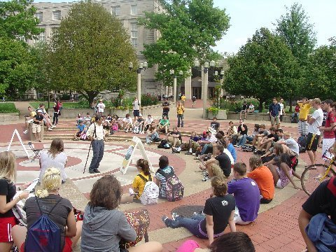
Mizzou

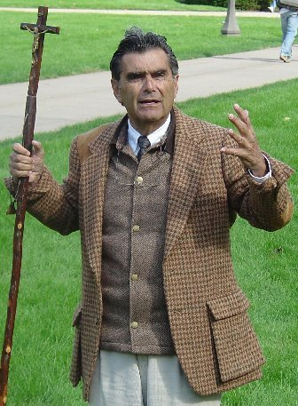
Iowa, October 2009

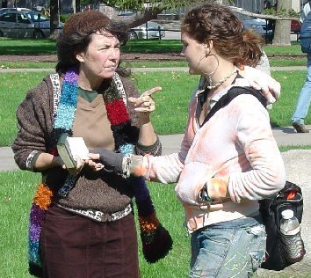
Sister Cindy in Iowa

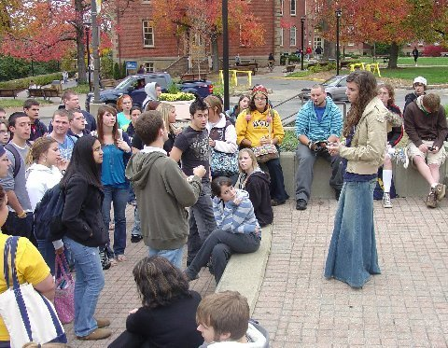
Martha at West Virginia, October 2009

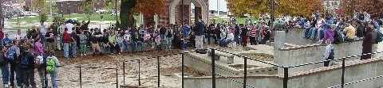

Large Crowds at Morehead State in Kentucky

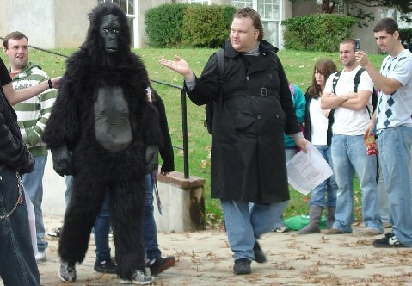

The Missing Link Appears!

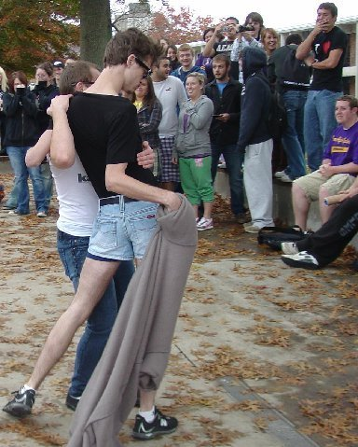

Sodomite Strippers

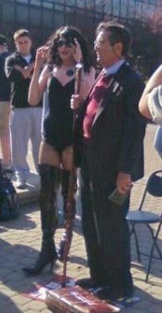
Pervert Confronts Bro. Jed at Indiana State University

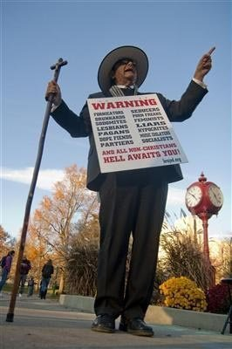
ISU November 2009

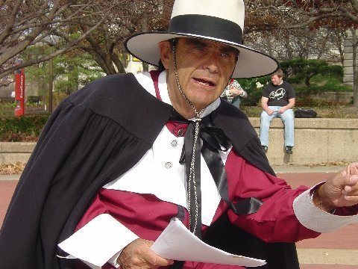
Teaching From Bradford's History of Plymouth Plantation at Mizzou

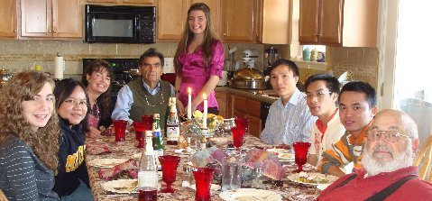

Thanksgiving Dinner:Left to Right: Priscilla, Rilya, Cindy, Jed,
Martha, Cuong, Dat, Jung and Bro Cope
The three men are Vietnamese students and Rilya is from Indonesia
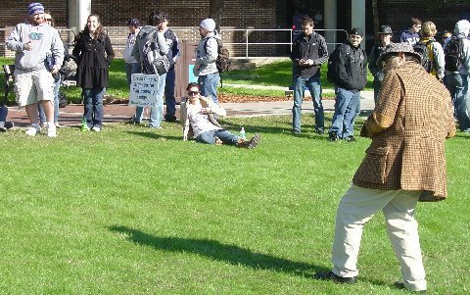

Drama at University of North Florida

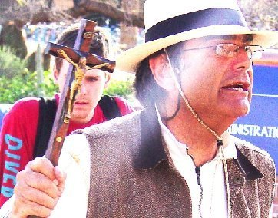
University of Arizona February 2010

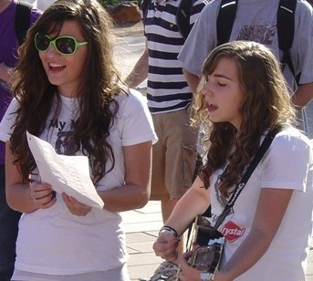
Martha and Priscilla, Arizona 2010

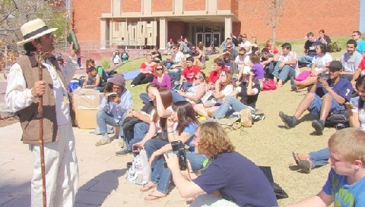
Some of the Largest Crowds this Year, UA

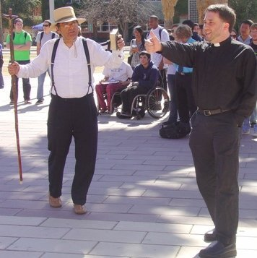
Debate With the Episcopal Priest

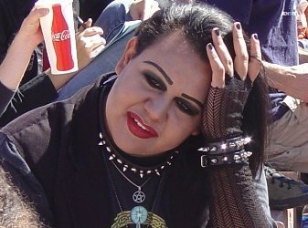
Strange Listeners

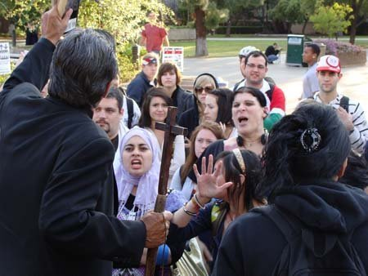
Battling the Muslims at ASU

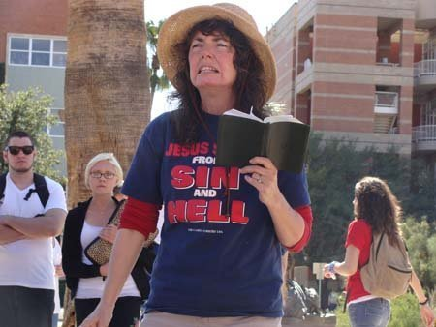
Sister Cindy at ASU

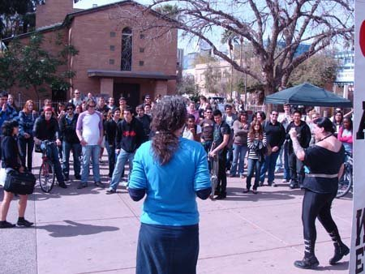

Sister Cindy and Lesbian Girl at ASU
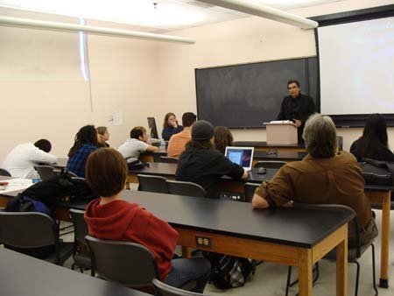

Bro. Jed Addresses the Secular Free Thought Society

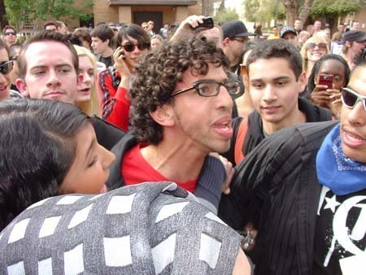
Peace-loving Muslim has to be held back from attacking Bro. Jed

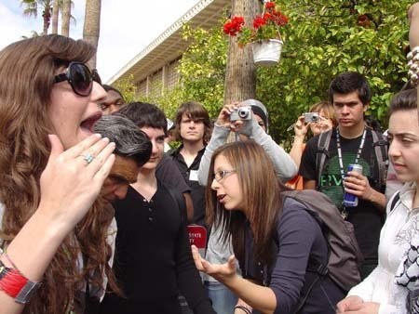
Martha Defends Her Dad Against the Muslim Girls

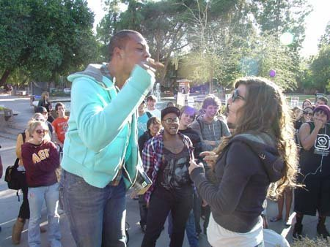
Sodomite Gets on a Chair to Yell at Martha

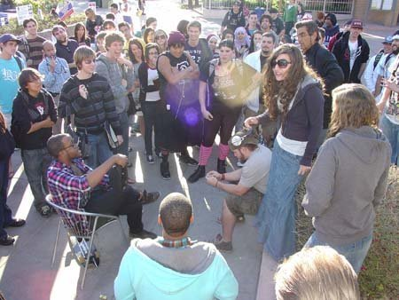

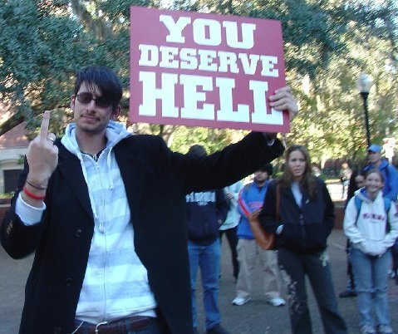
He Stole Our Sign!

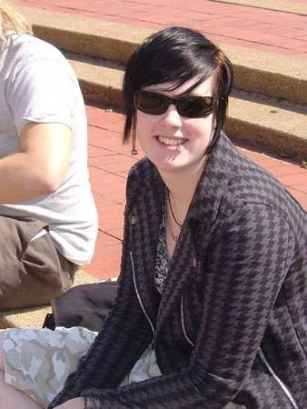
Regular Heckler at Mizzou

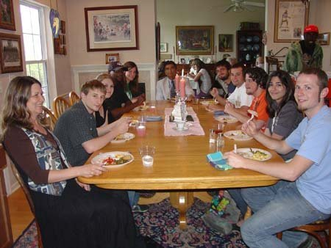
Dinner and Debate at the Smocks April 2010

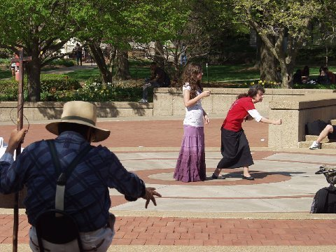

Sister Cindy preaching and Martha waiting to speak.
Note Bro. Jed preaching along with his wife:)
"The two shall be one."
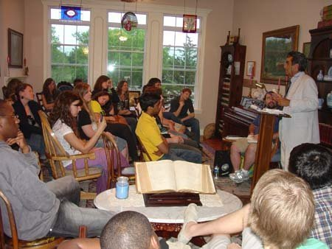
Over 45 Attended the Dinner and Debate--
Less that Half Were Christians
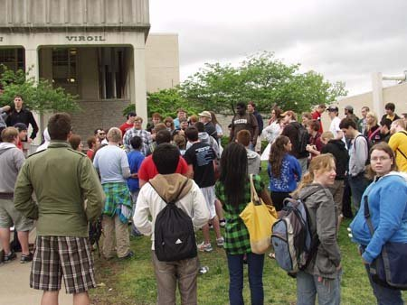
Bro Cope and Bro. Jed at Southeast Missouri State,
April 2010
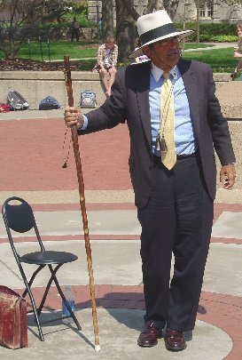
The Man in the Arena

Note From Sister Cindy:
Hello Saints of God,
I thought that you might enjoy this pictorial review and hopefully it will inspire you to pray for us. Bro. Jed is busy praying, meditating, planning, and yes even resting a little. On August 19th Bro. Jed and Martha start the new year of ministry at Kansas State. We need prayer warriors who are interceding and preparing the way now...for it is indeed a spiritual battle!
Prayer needs:
1) Saved souls
2) Revival on the Campuses
3) Bro. Jed's total healing in his back (he is lots better)
4) Financial Provisions
5) Safety for all those ministering on campuses
6) Open doors and freedom to proclaim the Everlasting Gospel of Jesus Christ.
Thank you all!

